

**School of computer application**

CA First

of

Programming in Java - LAB (CAP 680)

**Session 2022-2024**

**Submitted to: Submitted by:**

Name: Mr. Prince Arora Name: Satyam Mishra

(Dept of. Computer Science) Reg. no: 12212256

Course: MCA

**Department of computer Science**

**Lovely Professional University Jalandhar Punjab (144401)**

**India.**

**Code of Question 1**

import java.util.Scanner;

class Highest_Marks

{

    public static void main(String[] args) {

        String name;

        int s;

        int marks;

        Scanner in=new Scanner(System.in);

        System.out.println("Student in the Class");

        s=in.nextInt();

        System.out.println("Enter the name and marks of Student No.1");

        name=in.next();

        marks=in.nextInt();

        for(int i=2;i<=s;i++)

        {

            System.out.println("Enter the Name and marks of Student No."+i+" ");

            String na=in.next();

            int m=in.nextInt();

            if(m>marks)

            {

                marks=m;

                name=na;

            }

        }

        System.out.println("Name of the Student having Highest Marks :"+name+" "+marks);

        in.close();

    }

}

**Output of Code**

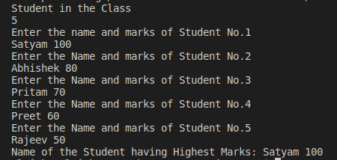

**Code of Question 2**

import java.util.* ;

public class Mouse_Hole

{

    public int MiceHole(ArrayList<Integer> mice,

                         ArrayList<Integer> holes)

    {

        if (mice.size() != holes.size())

           return -1;

        Collections.sort(mice);

        Collections.sort(holes);

        int size = mice.size();

        int max = 0;

        for (int i=0; i<size; i++)

            if (max < Math.abs(mice.get(i)-holes.get(i)))

                max = Math.abs(mice.get(i)-holes.get(i));

        return Math.abs(max);

    }

    public static void main(String[] args)

    {

        Mouse_Hole obj = new Mouse_Hole();

        ArrayList<Integer> mice = new ArrayList<Integer>();

        mice.add(4);

        mice.add(-4);

        mice.add(2);

        ArrayList<Integer> holes= new ArrayList<Integer>();

        holes.add(4);

        holes.add(0);

        holes.add(5);

        System.out.println("The last mouse gets into " +

        "the hole in time: "+obj .MiceHole(mice, holes));

    }

}

**Output of Code**